Grade 7 Accelerated · Unit 6 · Thread B · Day 1  Angle Pairs: Supplementary, Complementary, Vertical, Adjacent  Question Bank - Additional 6.T1 | Name______________________  Date______________________  Period____________________

Show your work. Circle your final answer.
For questions 1 through 4, find the angle.
1. The complement of 43°

2. The supplement of 151°

3. The angle vertical to a 66° angle

4. The angle that makes a linear pair with a 117° angle

For questions 5 through 7, find x and the angles.
5. 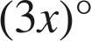 and 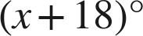 are complementary.

6. 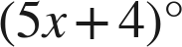 and 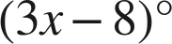 are a linear pair.

7. Vertical angles measure 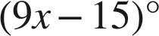 and 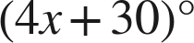.

Choose one.
8. Angles E and F are complementary, and angle E is 37°. What is angle F?
○ A. 143°
○ B. 37°
○ C. 127°
○ D. 53°

9. Vertical angles measure 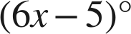 and 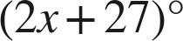. A student answers 8. What did the student find?
○ A. the value of x
○ B. the angle
○ C. the complement
○ D. the supplement

